NAME: NITHISH KUMAR K REG NO: 230701218

**EXP NO : 09**

**SUB QUERIES**

1. The HR department needs a query that prompts the user for an employee last name. The query then displays the last name and hire date of any employee in the same department as the employee whose name they supply (excluding that employee). For example, if the user enters Zlotkey, find all employees who work with Zlotkey (excluding Zlotkey).

SELECT e.last_name, e.hire_date FROM employees e JOIN employees e2 ON e.department_id = e2.department_id WHERE e2.last_name = :emp_name AND e.employee_id != e2.employee_id;

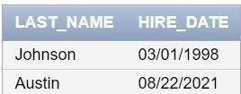

1. Create a report that displays the employee number, last name, and salary of all employees who earn more than the average salary. Sort the results in order of ascending salary.

SELECT employee_id, last_name, salary FROM employees WHERE salary > (SELECT AVG(salary) FROM employees) ORDER BY salary ASC;

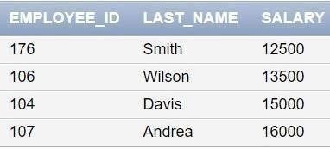

1. Write a query that displays the employee number and last name of all employees who work in a department with any employee whose last name contains a *u*.

SELECT DISTINCT e1.employee_id, e1.last_name FROM employees e1 JOIN employees e2 ON e1.department_id = e2.department_id WHERE e2.last_name LIKE '%u%';

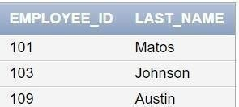

1. The HR department needs a report that displays the last name, department number, and job ID of all employees whose department location ID is 1700.

SELECT e.last_name, e.department_id, e.job_id FROM employees e

JOIN departments d ON e.department_id = d.department_id WHERE d.location_id = 1700;

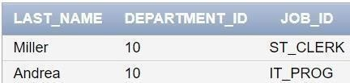

1. Create a report for HR that displays the last name and salary of every employee who reports to King.

SELECT e.last_name, e.salary FROM employees e JOIN employees m ON e.manager_id = m.employee_id WHERE m.last_name = 'King';

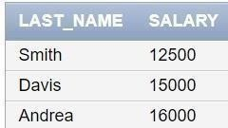

1. Create a report for HR that displays the department number, last name, and job ID for every employee in the Executive department.

SELECT e.department_id, e.last_name, e.job_id FROM employees e JOIN departments d ON e.department_id = d.department_id WHERE d.department_name = 'Executive';

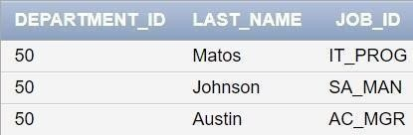

1. Modify the query 3 to display the employee number, last name, and salary of all employees who earn more than the average salary and who work in a department with any employee whose last name contains a *u*.

SELECT e1.employee_id, e1.last_name, e1.salary FROM employees e1

JOIN employees e2 ON e1.department_id = e2.department_id WHERE e2.last_name LIKE '%u%' AND e1.salary > (SELECT AVG(salary) FROM employees);

